HW03
Due on February 29, 2024 by 11:59 PM
William Wenzel

Problem 1 (10pts)
Consider a plant $G\left(s\right)=\frac{K}{Js^{2}+cs}$ with K=450, J=8, c=4.
  - Design a unit feedback closed loop system and derive its transfer function TF_{CL}(s).
We start with: $G\left(s\right)=\frac{K}{Js^{2}+Cs}=\frac{450}{8s^{2}+4s}$
$$TF_{CL}\left(s\right)=\frac{G\left(s\right)}{1+G\left(s\right)H\left(s\right)}$$
But, with H(s)=1,
$$TF_{CL}\left(s\right)=\frac{G\left(s\right)}{1+G\left(s\right)}=\frac{\frac{450}{8s^{2}+4s}}{1+\frac{450}{8s^{2}+4s}}=\frac{450}{8s^{2}+4s+450}$$

  - Plot the block diagram your design.
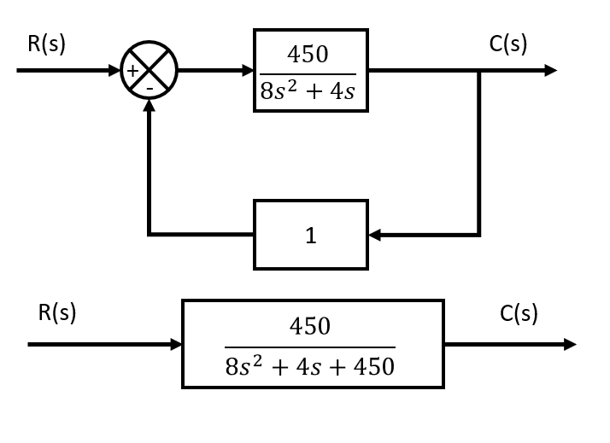
  - Find the poles of closed loop system
Standard form of 2nd order system: $G\left(s\right)=\frac{ω_{n}^{2}}{s^{2}+2ζω_{n}s+ω_{n}^{2}}$
$$TF_{CL}\left(s\right)=\frac{450}{8s^{2}+4s+450}$$
To convert to standard form, the variable in the 2nd order position mut be equivalent to 1. Thus, the following:
$$G\left(s\right)=\frac{56.25}{s^{2}+0.5s+56.25}$$
And we get: $ω_{n}=\sqrt{56.25}=7.5, ζ={0.5}/{2*7.5}=1/{30}$
Now, we can find the pole placement via the standard form for the pole placement of a 2nd order system.
$$p_{1,2}=-ζ⋅ω_{n}±j⋅ω_{n}*\sqrt{1-ζ^{2}}$$

$$p_{1,2}=-\frac{1}{30}⋅7.5±j⋅7.5*\sqrt{1-{\left(\frac{1}{30}\right)}^{2}}$$
$$p_{1,2}=-0.25±j⋅7.5*\sqrt{1-\frac{1}{900}}$$
$$p_{1,2}=-0.25±j⋅7.4958$$
  - Derive & plot the step response of the original system
From MATLAB: $y\left(t\right)=\frac{225}{2}-\frac{225⋅e^{-\frac{t}{2}}}{2}$
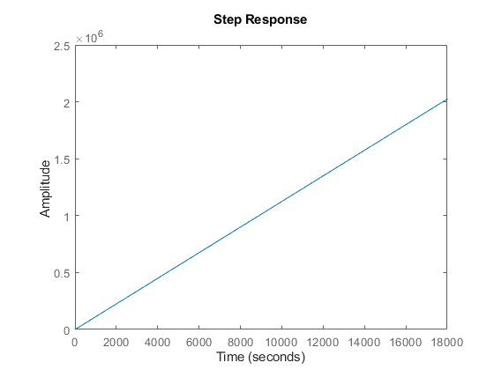
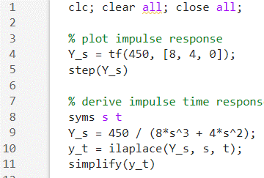

  - Derive & plot the step response of the closed loop system
The system step response is represented by
$$Y\left(s\right)=TF_{CL}\left(s\right)⋅U\left(s\right)=\frac{450}{8s^{2}+4s+450}*\frac{1}{s}=\frac{450}{8s^{3}+4s^{2}+450s}$$
We find $y\left(t\right)=1-e^{-\frac{t}{4}}\left(\cos\left(\frac{\sqrt{899}t}{4}\right)+\frac{\sqrt{899}}{899}⋅\sin\left(\frac{\sqrt{899}t}{4}\right)\right)$
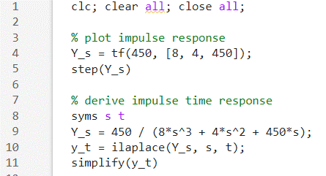
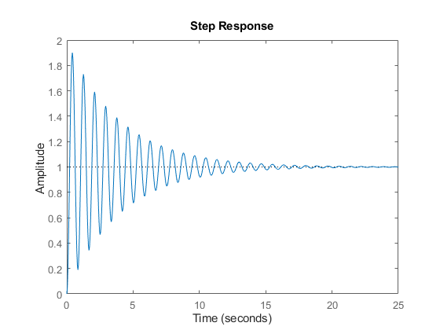
  - Use the Closed Loop step response plot to estimate the rise time 10% to 90% t_{r}, and the percentage overshoot, M_{p}.

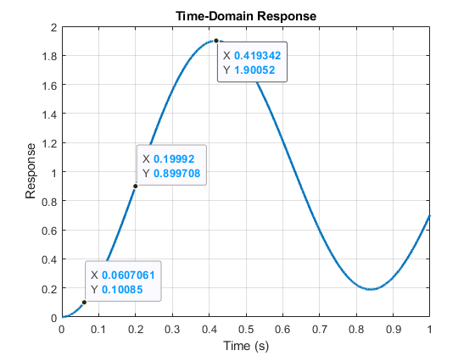
From MATLAB stepinfo(Y_s):
RiseTime: 0.1426
TransientTime: 15.5417
SettlingTime: 15.5417
SettlingMin: 0.1891
SettlingMax: 1.9005
Overshoot: 90.0523
Undershoot: 0
Peak: 1.9005
PeakTime: 0.4189

  - Show snips of the plot with data cursors showing the measurements; write the estimated results for t_{r} and M_{p}
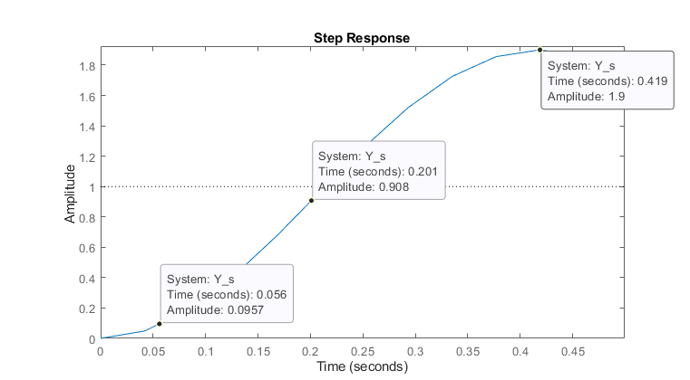
$$M_{p}=\frac{01.9-1}{1}=90\%$$
$$t_{r}=0.201-0.056=0.145 seconds$$

Problem 2
- find the poles of the feedback control system: (15pts)
$G(s)=\frac{5s+1}{2s+3}$ and $H(s)=\frac{5(s+2)}{s+10}$
The Transfer function of the Closed loop system can be found via $Y\left(s\right)=\frac{G\left(s\right)}{1+G\left(s\right)H\left(s\right)}$
$$Y\left(s\right)=\frac{\frac{5s+1}{2s+3}}{1+\frac{5s+1}{2s+3}*\frac{5(s+2)}{s+10}}=\frac{\left(s+10\right)\left(5s+1\right)}{\left(3s+2\right)\left(9s+20\right)}$$
Thus, the poles are: $s=-\frac{2}{3}≈0.66, s=-\frac{20}{9}≈-2.22$

- Calculate the steady state error for a unit feedback system with plant given below for step input (5pts) and ramp input (10pts), respectively.
$$G(s)=\frac{3s^{2}+4s+83}{16s^{7}+9s^{5}+17s^{4}+6s}$$

There are 2 solutions. Following the traditional definition, $e_{ss}=\lim_{t→∞}{e\left(t\right)}=\lim_{s→0}{s⋅E\left(s\right)}$ where E(s) is equivalent to the total transfer function of the system, not just the plant.

However, considering the transfer function of a unity feedback closed loop system can be found via $E\left(s\right)=\frac{G\left(s\right)}{1+G\left(s\right)}$, we can also solve for error with just the plant function.

We get $e_{ss}=\lim_{t→∞}{e\left(t\right)}=\lim_{s→0}{s⋅E\left(s\right)}=\lim_{s→0}{\frac{s⋅R\left(s\right)}{1+G\left(s\right)}}$, where R(s) is the input function.

For a step input r(t) with magnitude R, $R\left(s\right)=\frac{R}{s}$, thus $e_{ss}=\lim_{s→0}{\frac{s}{1+G\left(s\right)}⋅\frac{R}{s}}=\lim_{s→0}{\frac{R}{1+G\left(s\right)}}=\frac{R}{1+\lim_{s→0}{G\left(s\right)}}$

For convenience of solving, we set the limit to a variable called $K_{p}$ where p represents “position”.
$$K_{p}=\lim_{s→0}\left(G\left(s\right)\right), where e_{ss}=\frac{R}{1+K_{p}}$$
And for a traditional step or ramp input, R=1.
$$K_{p}=\lim_{s→0}\left(\frac{3s^{2}+4s+83}{16s^{7}+9s^{5}+17s^{4}+6s}\right)=\left(\frac{83}{0}\right)=∞$$
$$e_{ss}=\frac{1}{1+∞}≈0$$

For a ramp input r(t) with slope R, $R\left(s\right)=\frac{R}{s^{2}}$, thus $e_{ss}=\lim_{s→0}{\frac{s}{1+G\left(s\right)}⋅\frac{R}{s^{2}}}=\lim_{s→0}{\frac{R}{s+s⋅G\left(s\right)}}=\frac{R}{\lim_{s→0}{s⋅G\left(s\right)}}$
*Note that the additional “s” is removed since we can assume it goes to 0 from the limit.
For convenience of solving, we set the limit to a variable called $K_{v}$ where v represents “velocity”.
$$K_{v}=\lim_{s→0}\left(s⋅G\left(s\right)\right), where e_{ss}=\frac{R}{K_{v}}$$
$$K_{v}=\lim_{s→0}\left(\frac{s⋅(3s^{2}+4s+83)}{16s^{7}+9s^{5}+17s^{4}+6s}\right)=\lim_{s→0}\left(\frac{s⋅(3s^{2}+4s+83)}{s⋅\left(16s^{6}+9s^{4}+17s^{3}+6\right)}\right)=\frac{83}{6}$$
*Note, $\lim_{s→0}\left(\frac{s}{s}\right)=1$
$$e_{ss}=\frac{1}{\left({83}/6\right)}=\frac{6}{83}$$
Problem 3: Use Routh criterion to evaluate the stability of the following systems. You must show step by step derivation. (20pts)

- $s^{5}+2s^{4}+2s^{3}+4s^{2}+11s+10=0$

We first define our constants $a_{N}$ through $a_{0}$.
$$a_{5}=1;a_{4}=2;a_{3}=2;a_{2}=4;a_{1}=11;a_{0}=10$$

The following is a standard form of the Routh Array for a 5th order problem where N is equivalent to 5.
$$\begin{matrix}s^{5} \\ s^{4} \\ s^{3} \\ s^{2} \\ s^{1} \\ s^{0}\end{matrix}\left|\begin{matrix}a_{N} & a_{N-2} & a_{N-4} \\ a_{N-1} & a_{N-3} & a_{N-5} \\ b_{N-1} & b_{N-3} & b_{N-5} \\ c_{N-1} & c_{N-3} & c_{N-5} \\ d_{N-1} & d_{N-3} & d_{N-5} \\ e_{N-1} & e_{N-3} & e_{N-5}\end{matrix}\right.$$

From Control Systems by WikiBooks:
For each element in the 3rd row or later we use the following equation:
$$v=\frac{\left(l⋅m\right)-\left(k⋅n\right)}{l}$$
For each element we are computing,
- $l$ is the left-most element 1 row above the current row. This is also know as the ‘pivot element’.
- $k$ is the left-most element 2 rows above the current row.
- $m$ is the element 1 column to the right and 2 rows above the current element.
- $n$ is the element 1 column to the right and 1 row above the current element.

If any left-most element is 0, for calculation purposes, we replace it with $ϵ$, a vanishingly small number. This always gives you an answer of either 0, $∞$, or -$∞$ for the element in question.

Entering specifics into the array, we get:
$$\begin{matrix}s^{5} \\ s^{4} \\ s^{3} \\ s^{2} \\ s^{1} \\ s^{0}\end{matrix}\left|\begin{matrix}a_{5} & a_{3} & a_{1} \\ a_{4} & a_{2} & a_{0} \\ b_{4}=\frac{\left(a_{4}⋅a_{3}\right)-\left(a_{5}⋅a_{2}\right)}{a_{4}} & b_{2}=\frac{\left(a_{4}⋅a_{1}\right)-\left(a_{5}⋅a_{0}\right)}{a_{4}} & b_{0}=\frac{\left(a_{4}⋅0\right)-\left(a_{5}⋅0\right)}{a_{4}} \\ c_{4}=\frac{\left(b_{4}⋅a_{2}\right)-\left(a_{4}⋅b_{2}\right)}{b_{4}} & c_{2}=\frac{\left(b_{4}⋅a_{0}\right)-\left(a_{4}⋅b_{0}\right)}{b_{4}} & c_{0}=\frac{\left(b_{4}⋅0\right)-\left(a_{4}⋅0\right)}{b_{4}} \\ d_{4}=\frac{\left(c_{4}⋅b_{2}\right)-\left(b_{4}⋅c_{2}\right)}{c_{4}} & d_{2}=\frac{\left(c_{4}⋅0\right)-\left(b_{4}⋅0\right)}{c_{4}} & d_{0}=\frac{\left(c_{4}⋅0\right)-\left(b_{4}⋅0\right)}{c_{4}} \\ e_{4}=\frac{\left(d_{4}⋅c_{2}\right)-\left(c_{4}⋅d_{2}\right)}{d_{4}} & e_{2}=\frac{\left(d_{4}⋅0\right)-\left(c_{4}⋅0\right)}{d_{4}} & e_{0}=\frac{\left(d_{4}⋅0\right)-\left(c_{4}⋅0\right)}{d_{4}}\end{matrix}\right.$$
$$\begin{matrix}s^{5} \\ s^{4} \\ s^{3} \\ s^{2} \\ s^{1} \\ s^{0}\end{matrix}\left|\begin{matrix}a_{5}=1 & a_{3}=2 & a_{1}=11 \\ a_{4}=2 & a_{2}=4 & a_{0}=10 \\ b_{4}=\frac{\left(2⋅2\right)-\left(1⋅4\right)}{2}=0 & b_{2}=\frac{\left(2⋅11\right)-\left(1⋅10\right)}{2}=6 & b_{0}=0 \\ c_{4}=\frac{\left(ϵ⋅4\right)-\left(2⋅6\right)}{ϵ}=-∞ & c_{2}=\frac{\left(ϵ⋅10\right)-\left(2⋅0\right)}{ϵ}=0 & c_{0}=0 \\ d_{4}=\frac{\left(-∞⋅6\right)-\left(0⋅10\right)}{-∞}=6 & d_{2}=0 & d_{0}=0 \\ e_{4}=\frac{\left(6⋅0\right)-\left(-∞⋅0\right)}{6}=0 & e_{2}=0 & e_{0}=0\end{matrix}\right.$$
$$\begin{matrix}s^{5} \\ s^{4} \\ s^{3} \\ s^{2} \\ s^{1} \\ s^{0}\end{matrix}\left|\begin{matrix}1 & 2 & 11 \\ 2 & 4 & 10 \\ 0 & 6 & 0 \\ -∞ & 0 & 0 \\ 6 & 0 & 0 \\ 0 & 0 & 0\end{matrix}\right.$$

Since there IS a sign change in the left-most column, the system IS unstable.

- $s^{3}+s^{2}+2s+2=0$

We first define our constants $a_{N}$ through $a_{0}$.
$$a_{3}=1;a_{2}=1;a_{1}=2;a_{0}=2$$

We have a standard Routh array as follows:
$$\begin{matrix}s^{3} \\ s^{2} \\ s^{1} \\ s^{0}\end{matrix}\left|\begin{matrix}a_{N} & a_{N-2} \\ a_{N-1} & a_{N-3} \\ b_{N-1} & b_{N-3} \\ c_{N-1} & c_{N-3}\end{matrix}\right.$$

$$\begin{matrix}s^{3} \\ s^{2} \\ s^{1} \\ s^{0}\end{matrix}\left|\begin{matrix}a_{3} & a_{1} \\ a_{2} & a_{0} \\ b_{2} & b_{0} \\ c_{2} & c_{0}\end{matrix}\right.$$

$$\begin{matrix}s^{3} \\ s^{2} \\ s^{1} \\ s^{0}\end{matrix}\left|\begin{matrix}a_{3}=1 & a_{1}=2 \\ a_{2}=1 & a_{0}=2 \\ b_{2}=\frac{\left(a_{2}⋅a_{1}\right)-\left(a_{3}⋅a_{0}\right)}{a_{2}}=0 & b_{0}=0 \\ c_{2}=\frac{\left(b_{2}⋅a_{0}\right)-\left(a_{2}⋅b_{0}\right)}{b_{2}}=0 & c_{0}=0\end{matrix}\right.$$

Since there are NO sign changes in left-most column, system is stable.

Problem 4
- Use Routh criterion to find the stability range of K for the feedback control system illustrated below. Show your hand derivation step by step. (15pt)
$G\left(s\right)=\frac{1}{(s+2)(s+8)}$, $H\left(s\right)=K+\frac{12K}{s}$

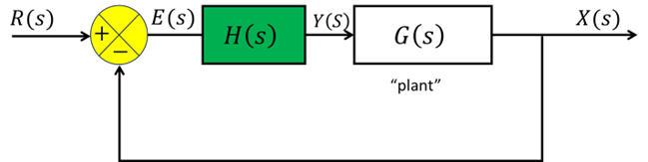

Combined upper equation becomes:
$$G_{H}\left(s\right)= G\left(s\right)*H\left(s\right)=\left(\frac{1}{\left(s+2\right)\left(s+8\right)}\right)*\left(K+\frac{12K}{s}\right)$$
$$=\left(\frac{1}{\left(s+2\right)\left(s+8\right)}\right)*\left(\frac{Ks}{s}+\frac{12K}{s}\right)$$
$$=\left(\frac{1}{\left(s+2\right)\left(s+8\right)}\right)*\left(\frac{Ks+12K}{s}\right)$$
$$=\frac{Ks+12K}{\left(s+2\right)\left(s+8\right)s}$$
Closed loop form:
$$\frac{X\left(s\right)}{R\left(s\right)}=\frac{G_{H}\left(s\right)}{1+G_{H}\left(s\right)}$$

Remember, if $G_{H}\left(s\right)=\frac{n_{umerator}}{d_{enominator}}$, then$\frac{X\left(s\right)}{R\left(s\right)}=\frac{n}{d+n}$

$$\frac{X\left(s\right)}{R\left(s\right)}=\frac{\frac{Ks+12K}{\left(s+2\right)\left(s+8\right)s}}{1+\frac{Ks+12K}{\left(s+2\right)\left(s+8\right)s}}=\frac{Ks+12K}{\left(s+2\right)\left(s+8\right)s+Ks+12K}$$

Then, to find the ‘characteristic equation’, we set the denominator equal to zero.
$$\frac{Ks+12K}{\left(s+2\right)\left(s+8\right)s+Ks+12K}→\left(s+2\right)\left(s+8\right)s+Ks+12K=0$$

Simplifying the equation into standard format:
$$\left(s+2\right)\left(s+8\right)s+Ks+12K→\left(s^{2}+10s+16\right)s+Ks+12K$$
$$=s^{3}+10s^{2}+16s+Ks+12K$$
$$=s^{3}+10s^{2}+\left(16+K\right)s+12K$$

We can now define our constants $a_{N}$ through $a_{0}$.
$$a_{3}=1;a_{2}=10;a_{1}=16+K;a_{0}=12K$$

We have a standard Routh array as follows:
$$\begin{matrix}s^{3} \\ s^{2} \\ s^{1} \\ s^{0}\end{matrix}\left|\begin{matrix}a_{N} & a_{N-2} \\ a_{N-1} & a_{N-3} \\ b_{N-1} & b_{N-3} \\ c_{N-1} & c_{N-3}\end{matrix}\right.$$

$$\begin{matrix}s^{3} \\ s^{2} \\ s^{1} \\ s^{0}\end{matrix}\left|\begin{matrix}a_{3} & a_{1} \\ a_{2} & a_{0} \\ b_{2} & b_{0} \\ c_{2} & c_{0}\end{matrix}\right.$$

$$\begin{matrix}s^{3} \\ s^{2} \\ s^{1} \\ s^{0}\end{matrix}\left|\begin{matrix}a_{3}=1 & a_{1}=16+K \\ a_{2}=10 & a_{0}=12K \\ b_{2}=\frac{\left(a_{2}⋅a_{1}\right)-\left(a_{3}⋅a_{0}\right)}{a_{2}}=\frac{\left(10⋅\left(16+K\right)\right)-\left(1⋅12K\right)}{10}=16-\frac{K}{5} & b_{0}=0 \\ c_{2}=\frac{\left(b_{2}⋅a_{0}\right)-\left(a_{2}⋅b_{0}\right)}{b_{2}}=\frac{\left(\left(16-\frac{K}{5}\right)⋅12K\right)-\left(10⋅0\right)}{16-\frac{K}{5}}=12K & c_{0}=0\end{matrix}\right.$$
The system is stable while $12K>0$ AND $16-\frac{K}{5}>0$.
From $12K>0$, we get that $K>0$
And from $\left(16-\frac{K}{5}\right)>0→\left(80-K\right)>0→K<80$
Thus, stability lies in the range of $0<K<80$

- Set a value for K and plot the step response for the feedback system for
  - Not meeting the design requirement.
  - Meeting the design requirement.
Mark in your plots the value of K you select for the plots. (5pts)
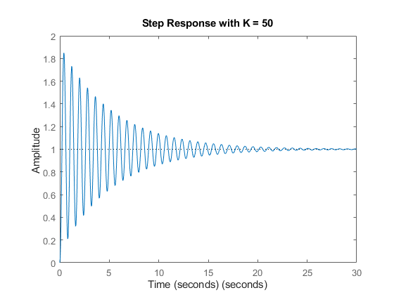

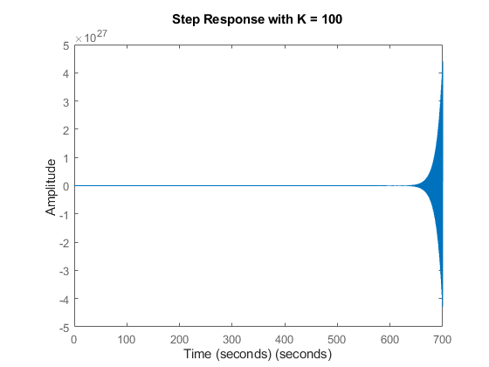

MATLAB Code:
% Define the system constants
K = 50; % K outside the stability range

% Create the transfer function for the system
num = [K K*12]; % Numerator coefficients
den = [1 10 16+K 12*K]; % Denominator coefficients
system = tf(num, den);

% Plot the step response
figure;
step(system);
title(['Step Response with K = ', num2str(K)]);
xlabel('Time (seconds)');
ylabel('Amplitude');

Problem 5 Root locus method
- Derive (not by software tool) the root locus of the system given below. You need to show your work on the five essential steps. With the results, hand sketch the RL. (10pts)
$$G\left(s\right)=\frac{K}{(s+2)(s+1)(s+4)}$$
#1. Poles and zeros including if you have infinite zeros:
First, Identifying the poles:
$$s=-2, -1, -4$$
There are no zeros.

#2. Number of branches
The number of branches is equivalent to the number of poles in the transfer function, being 3 in this case.

#3. Real axis segment(s)
For any point between $s=-2$, and $s=-1$, there are one poles to the right of it ($s=-1$). Since this is an odd number of poles, this segment is a part of the root locus.

For any point between $s=-4$, and $s=-2$, there are two poles to the right of it ($s=-2,-1$). Since this is an even number of poles, this segment is NOT a part of the root locus.

For any point between $s=-∞$, and $s=-4$, there are three poles to the right of it ($s=-1,-2,-4$). Since this is an odd number of poles, this segment is part of the root locus.

#4. Breakaway points in real axis

Since the breakaway is determined by $\frac{dK}{ds}=0$, we first solve for K.
From the Characteristic Equation: $G\left(s\right)+1=0$, we get:
$$→1+\frac{K}{\left(s+2\right)\left(s+1\right)\left(s+4\right)}=0$$
$$→K=-\left(s+2\right)\left(s+1\right)\left(s+4\right)$$
$$→ K=-\left(s+2\right)\left(s^{2}+5s+4\right)=-\left(s^{3}+5s^{2}+4s+2s^{2}+10s+8\right)$$

Then we differentiate:
$$\frac{d\left(-\left(s^{3}+5s^{2}+4s+2s^{2}+10s+8\right)\right)}{ds}=-3s^{2}-14s-14=0$$
$$-3s^{2}-14s-14=0→s=-\frac{7}{3}±\frac{\sqrt{7}}{3}$$
Since $s=-\frac{7}{3}-\frac{\sqrt{7}}{3}$ does not fall on any of the real axis segments, it is NOT a breakaway point.
Thus, the ONLY breakaway point is $s=-\frac{7}{3}+\frac{\sqrt{7}}{3}≈-1.45$.

#5. Asymptotes locations and angles if deemed needed
The asymptotes of the root locus give the directions in which the branches approach infinity. The formula for the angles of the asymptotes is given by $θ=\frac{\left(2k+1\right)*180°}{p-z}$ for $k=0,1,2, … p-z-1,$where $p$ is the number of finite poles and $z$ is the number of finite zeros. In this case, $p=3$ and $z=0$, so the angles of the asymptotes are:
$$θ_{0}=\frac{\left(2*0+1\right)*180°}{3}=60°$$
$$θ_{1}=\frac{\left(2*1+1\right)*180°}{3}=180°$$
$$θ_{2}=\frac{\left(2*2+1\right)*180°}{3}=300°$$
Note that $θ_{1}$ is not considered a traditional asymptote as it goes straight left.

The center of the asymptotes $σ$ is found by averaging the poles minus the average of the zeros.
$$σ=\frac{\sum{\left(real parts of poles\right)-\sum{\left(real parts of zeros\right)}}}{p-z}=\frac{-1-2-4}{3}=-\frac{7}{3}≈-2.33$$

GRAPH Root Locus
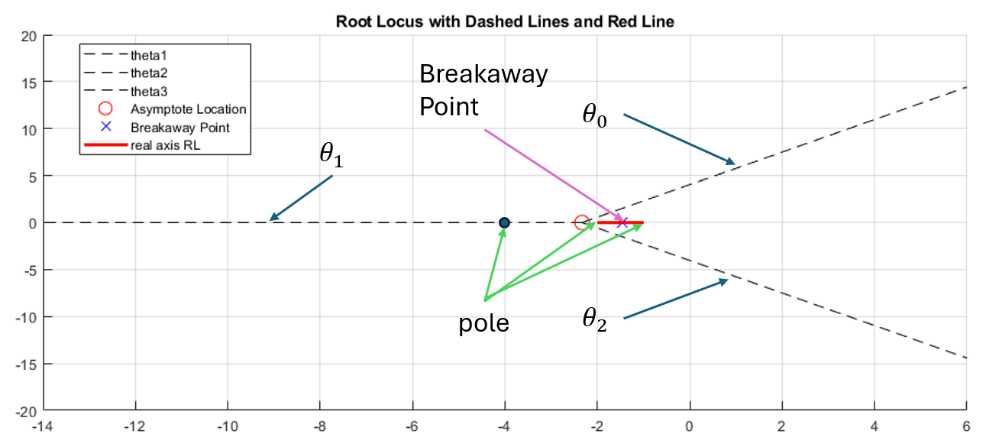

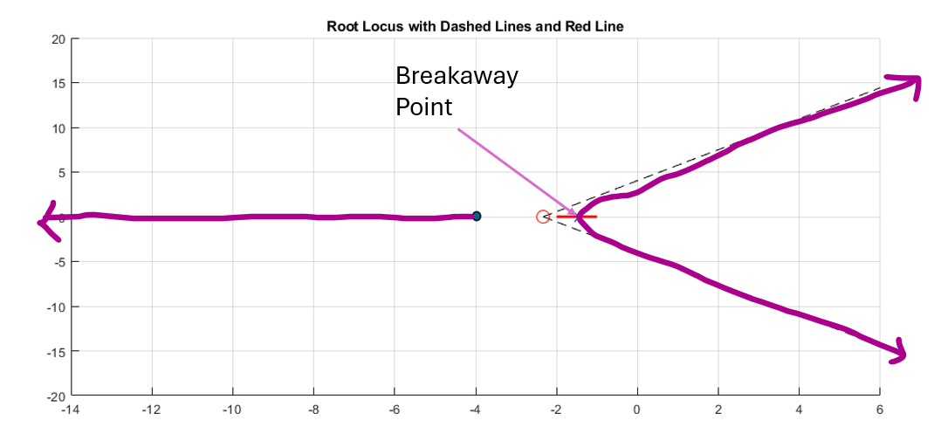

- Now use MATLAB rlocus() function to plot the RL. Paste your codes and resulting plot below. (5pts)
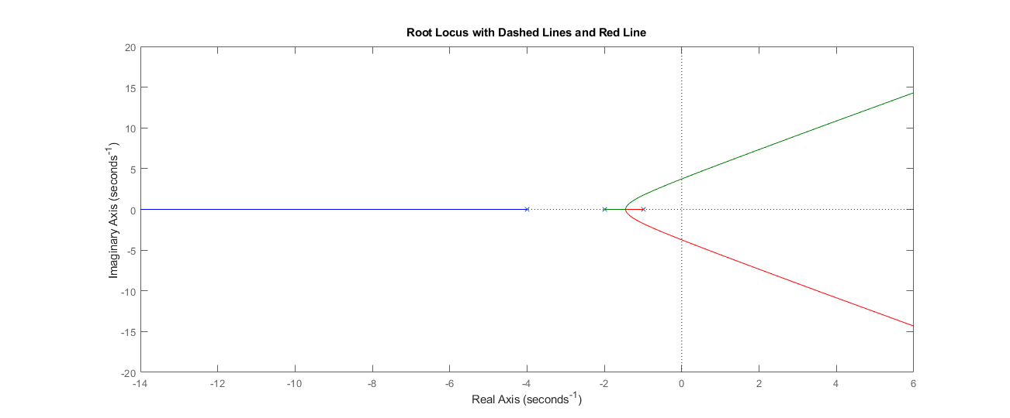
num = [1]; % Coefficient(s) of the numerator
den = [1,7,14,8]; % Convolution combines the polynomial factors of the denominator
G = tf(num, den);

figure;
rlocus(G); % Uncomment this to display the root locus
hold on; % Hold on to add more plots to the current figure
title('Root Locus with Dashed Lines and Red Line');

grid off; % Turn on the grid for better readability
axis on;
xlim([-14, 6]);
ylim([-20, 20]);

- We need to design a controller that satisfies $t_{r}<1 s$, $M_{p}<5\%$. Draw the geometric constraints on your Root Locus plot. You can use MATLAB to do so (hint: sgrid()) or use drawing tool. Please mark clearly the values in the plot. And show where are the applicable root loci range. You can do so by using drawing tool.
In the identified range, choose a locus point and identify the K value. Find and plot the step response with this K value of the control system. (5pts)

For a Maximum overshoot of 5%,
$$M_{p}=5=e^{\frac{-ζπ}{\sqrt{1-ζ^{2}}}}*100\%$$
$$5=e^{\frac{-ζπ}{\sqrt{1-ζ^{2}}}}*100\%→ζ≈0.69$$
And to plot it, we can find the damping ratio angle from the origin as: $θ=180°-\cos^{-1}\left(ζ\right)$

$$θ=180°-\cos^{-1}\left(0.69\right)≈133.63°$$

For a rise time of 1 second, we can approximate it as $t_{r}≈\frac{1.8}{ω_{n}}$
This gives us $ω_{n}=1.8$

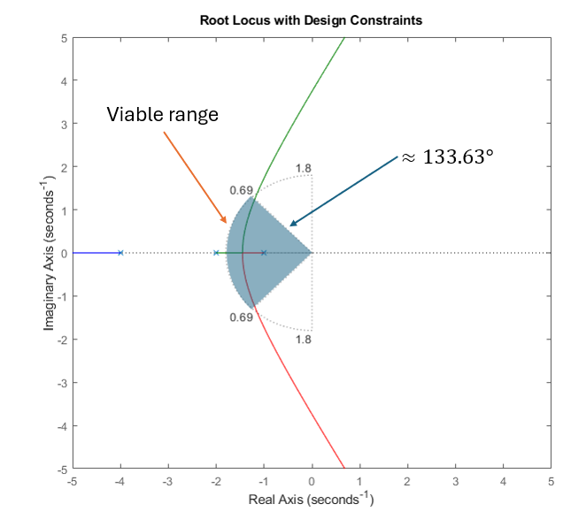
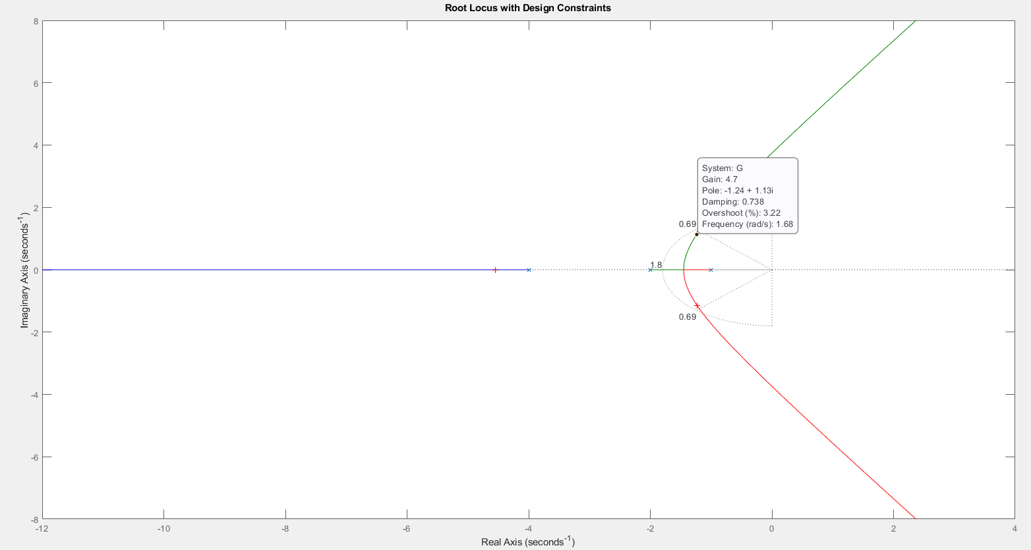

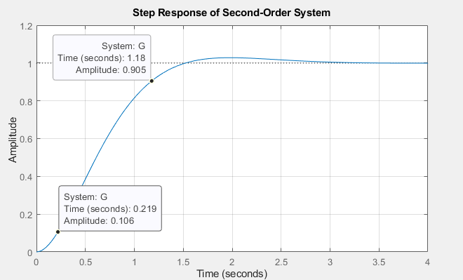

clc;
clear all;
close all;

num = 1;
den = [1, 7, 14, 8];
G = tf(num, den);

figure;
rlocus(G);
hold on;

title('Root Locus with Design Constraints');
sgrid(0.69, 1.8); % This will draw the necessary lines for zeta and wn
[K,poles] = rlocfind(G); % User selects a point on the root locus

% Calculate the closed-loop transfer function
sys_cl = feedback(K*G, 1);

% Plot the step response of the closed-loop system
figure; % Open a new figure window
step(sys_cl);
stepinfo(sys_cl)
title('Step Response of Closed-Loop System');
grid on;

